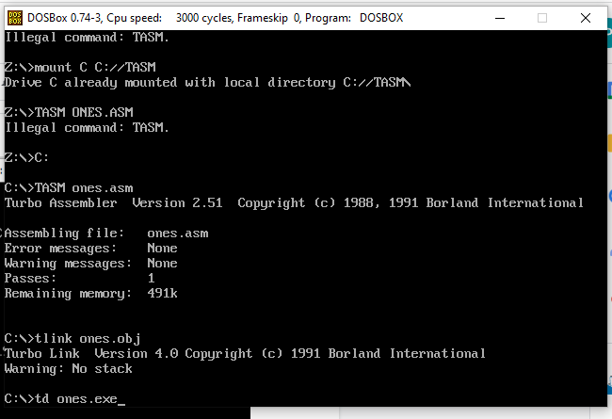

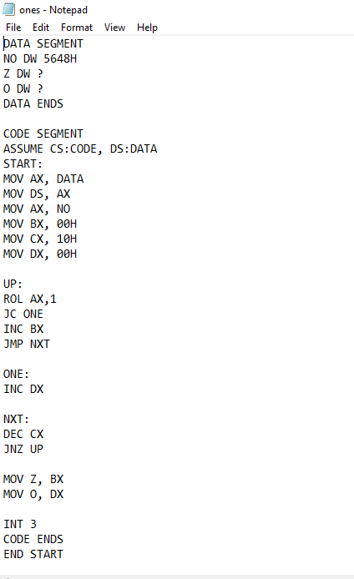

When you give 16 bit BCD how many ones and zero are there in it we have to count in this program

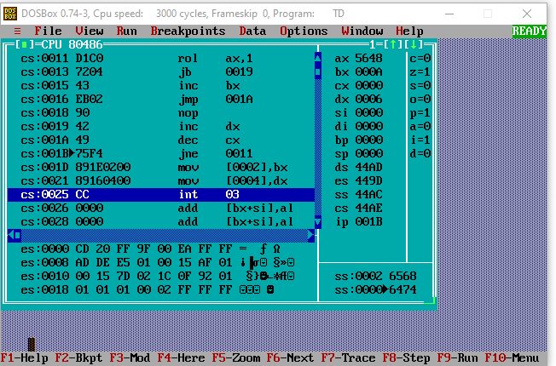

In above keep pressing f7 until cx comes 0000 in the resistor window in above image it is the window in the rightside i.e:

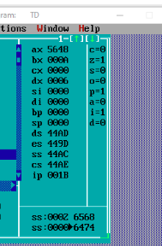

There ax is the number which we want to check bx is number of 0

Dx is number of ones in the number which was in ax